**PROJECT DESIGN PHASE-1**

**SOLUTION ARCHITECTURE**

|  |  |
| --- | --- |
| Date | 05 May 2023 |
| Team ID | NM2023TMID01588 |
| Project Name | SMARTCITY WASTE MANAGEMENT  SYSTEM WITH CONNECTED TRASHCANS |
| Maximum Marks | 4 Marks |

**SMARTCITY WASTE MANAGEMENT SYSTEM WITH CONNECTED TRASH CANS**

# **Main Objective:**

The main objective of the project is to design a smart city waste management which will help in keeping our environment clean and also ecofriendly.

# **Introduction:**

* At the present time, our environment is being polluted by massive deposits of global waste. This will have a catastrophic effect on human life and the surroundings. It was anticipated that the global waste will grow by 70% by 2050 unless immediate necessary, measure of monitoring and control are put in place, according to World Bank report.
* This architecture IoT based smart city waste management is a very innovative system which will help to keep the cities clean.
* It has a large role to play in future of smart cities which in turn are supposed to be environment friendly.
* The basic idea in this architecture is to design a smart Garbage system which would automatically notify the officials about the current status of various garbage bins in the city.
* With IoT in place, it will become easier for municipal bodies to monitor the whole waste management process in the cities.
* The waste management system with trash cans in a city will become more systematic and yield better results.

# **BLOCK DIAGRAM:**

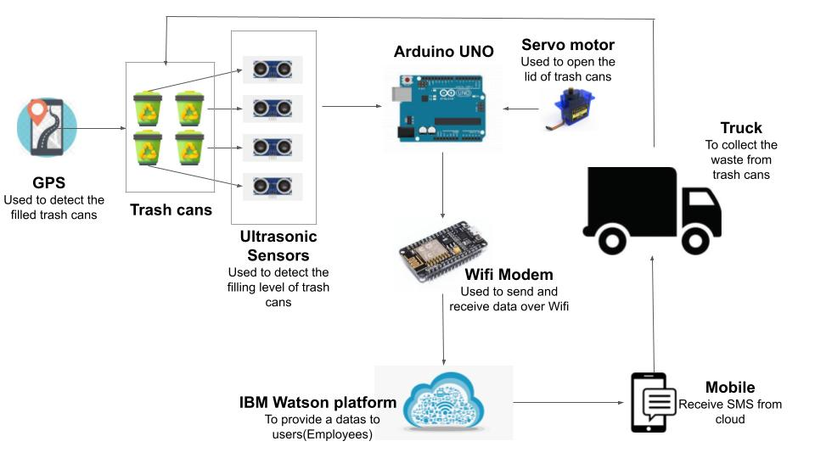

# **Arduino Uno:**

* Arduino Uno is a microcontroller board on the Atmega328P. It has 14 digital input/output pins, 6 analog inputs, a 16 MHz quartz crystal.
* Arduino boards are able to read inputs-light on a sensor, a finger on a button, or a Twitter message- and turn it into an output -activating motor, publishing something online.
* It processes the data and facilitates the proper working of the IoT system.

# **Wi-fi modem:**

* The ESP8266 wi-fi module is a self contained SOC with integrated TCP/IP protocol stack that can give any modules access to your wi-fi network.
* Wi-fi modules are used to send and receive data over wi-fi.
* Wi-fi modules are used for communication between devices. Mostly wi-fi modules used in the field of IoT.

# **Ultrasonic Sensor:**

* Ultrasonic sensors work on a principle of a target by interpreting the echoes from radio or sound waves respectively.
* Ultrasonic sensors generate high frequency sound waves and evaluate the echo which is received back by the sensor.
* Ultrasonic sensors placed over the bins to detect the garbage level and compare it with the garbage bins depth.

# **Servo Motor:**

* A servo motor is an electrical device which can push or rotate an object with great precision.
* In the architecture, servo motor is used to open the lid of the bin whenever someone is putting some trash in it.

# **IBM Watson platform:**

* Completely manage your IoT landscape and make better business decisions.
* Using a secure, smart and scalable platform as the hub of your IoT, get real-time analysis of user, including speech, text, video and social sentiment.
* Here it is provide SMS to the user.

# **Mobile:**

* When the trash can is filled employee mobile receives SMS via cloud.
* Then garbage collection truck driver will collect the filled garbage.

# **Conclusion:**

* Through this process Municipal Corporation making the cities clean.
* It is very difficult for them to monitor all the garbage placed across the city so through this system the process can be easy.
* If the city is clean, diseases can be prevented from spreading.
* This solution architecture is the step toward to making a smart city.